EXPERIMENT 1
(A)
Write an SQL solution to calculate the total number of bank accounts belonging to each salary category. The classification categories are:
- "Low Salary": All monthly salaries strictly less than $20,000.
- "Average Salary": All monthly salaries in the inclusive range [$20,000, $50,000].
- "High Salary": All monthly salaries strictly greater than $50,000. The final result table must report all three categories, even if a category contains zero accounts.
CODE:
CREATE TABLE Accounts (
aid INT PRIMARY KEY,
income INT NOT NULL);
INSERT INTO Accounts (aid, income) VALUES
(3, 108939),
(2, 12747),
(8, 87709),
(6, 91738),
(7, 45169);
SELECT 'Low Salary' AS category, COUNT(aid) AS accounts_count
FROM Accounts
WHERE income < 20000
UNION ALL
SELECT 'Average Salary' AS category, COUNT(aid) AS accounts_count
FROM Accounts
WHERE income >= 20000 AND income <= 50000
UNION ALL
SELECT 'High Salary' AS category, COUNT(aid) AS accounts_count FROM Accounts
WHERE income > 50000;
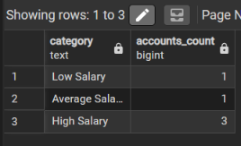

(B)
Design an Employee Management System database architecture by implementing the following operations sequentially:
- Create and populate structural tracking tables for Departments, Employees, and Salaries.
- Query the system using multi-table Joins to pull clear department breakdowns, apply a 10% salary enhancement across all members of the HR department, and delete any individual salary record dropping strictly below $30,000.
List all remaining active employees whose personal salary exceeds the overall company-wide average salary.
CODE:
SELECT e.name, d.dept_name, s.salary
FROM Employees AS e JOIN Departments AS d
ON e.dept_id = d.dept_id
JOIN Salaries AS s ON e.emp_id = s.emp_id;

UPDATE Salaries SET salary = salary * 1.10
WHERE emp_id IN (
SELECT e.emp_id
FROM Employees e JOIN Departments d
ON e.dept_id = d.dept_id
WHERE d.dept_name = 'HR');

select * from Salaries;
SELECT e.name, s.salary
FROM Employees AS e
JOIN Salaries AS s
ON e.emp_id = s.emp_id
WHERE s.salary > (SELECT AVG(salary) FROM Salaries);
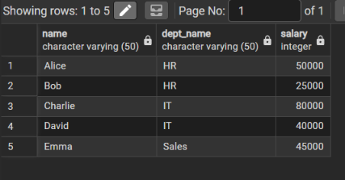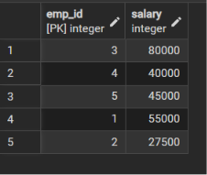
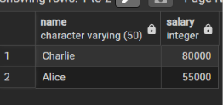

(C)
A pizza restaurant stores all the available pizza toppings and their ingredient costs in a table called pizza_toppings.
Every customer must choose exactly 3 different toppings to prepare a pizza.
Write a PostgreSQL query to generate every possible 3-topping pizza combination along with its total ingredient cost.
Requirements
Every pizza must contain exactly 3 different toppings.
The same topping cannot appear more than once in a pizza.
Different arrangements of the same toppings should be considered the same pizza.
Example:
Chicken, Pepperoni, Sausage
Pepperoni, Chicken, Sausage
Sausage, Chicken, Pepperoni
These are all the same pizza, so only one should appear.
Display the topping names separated by commas.
Display the total ingredient cost of each pizza.
Sort the output:
First by highest total cost
If two pizzas have the same cost, sort them alphabetically.
CODE:
SELECT
-- 1. Concatenate the three distinct topping names with commas
CONCAT(t1.topping_name, ',', t2.topping_name, ',', t3.topping_name) AS pizza,
-- 2. Sum the individual ingredient costs for the total cost
(t1.ingredient_cost + t2.ingredient_cost + t3.ingredient_cost) AS total_cost
FROM pizza_toppings t1
-- Join a second instance of the table where alphabetical order is enforced
INNER JOIN pizza_toppings t2
ON t1.topping_name < t2.topping_name
-- Join a third instance of the table maintaining the alphabetical order chain
INNER JOIN pizza_toppings t3
ON t2.topping_name < t3.topping_name
-- Sort first by highest total cost, then alphabetically by the pizza string
ORDER BY
total_cost DESC,
pizza ASC;

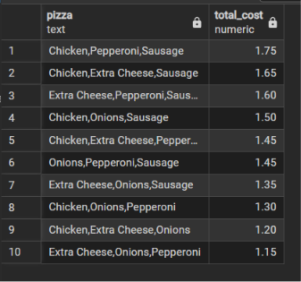

(D)
Amazon wants to identify returning customers who made another purchase shortly after their first purchase.
Write a PostgreSQL query to find all users who made another purchase within 1 to 7 days of an earlier purchase.
Requirements
- Compare purchases made by the same user only.
- Ignore comparisons where the same transaction is matched with itself.
- The second purchase must occur after the first purchase.
- Same-day purchases must not be considered.
- The second purchase must occur within 7 days of the first purchase.
- Display only the unique User IDs that satisfy the above conditions.
- Sort the output in ascending order of user_id.
CODE:
SELECT DISTINCT t1.user_id
FROM amazon_transactions t1
INNER JOIN amazon_transactions t2
ON t1.user_id = t2.user_id
WHERE
-- Ensures the second transaction happens on a later day (ignores same-day/same-id matches)
t2.created_at::date > t1.created_at::date
-- Restricts the second transaction to occur within 7 days of the first transaction
AND t2.created_at::date <= t1.created_at::date + INTERVAL '7 days'
ORDER BY t1.user_id ASC;

